ASSIGNMENT 3 DATA TRANSFORMATION AND DATA MODELING

FATHIMA MINHA P
● Import “List of Orders.csv” into Power BI.
Go to get data and select the text/csv and import into power bi
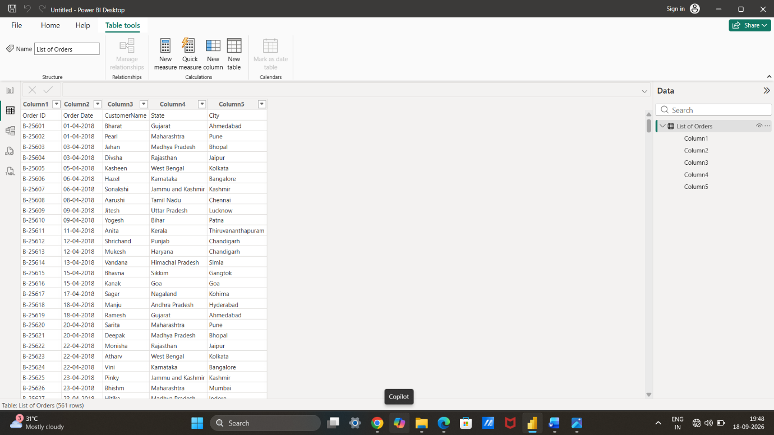
● Open “List of Orders” in Power Query Editor by clicking on ‘Transform’.
Go to the home tab select the transform data .
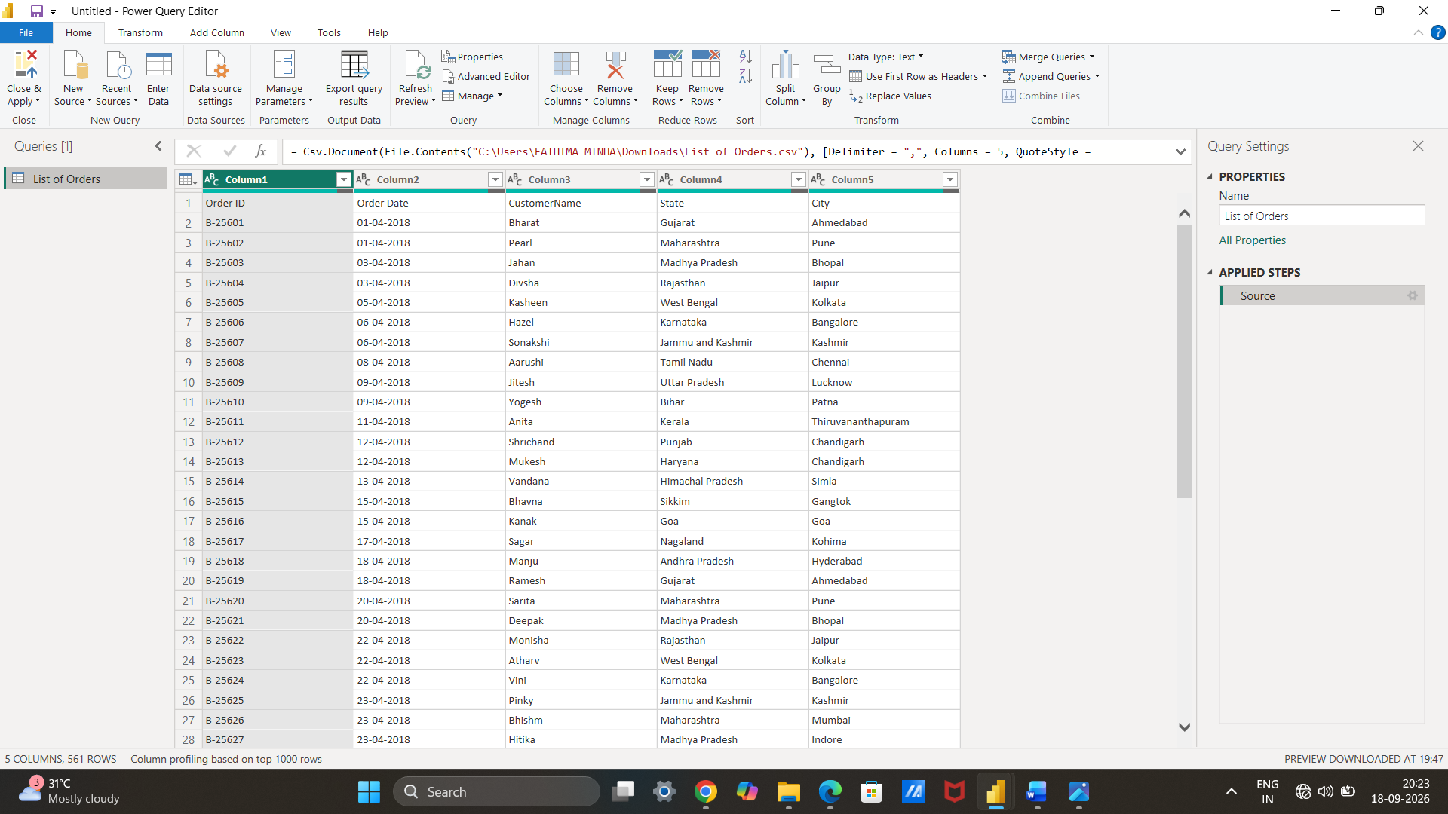
● Import “Order Details.csv” and “Sales target.csv” into Power Query Editor.
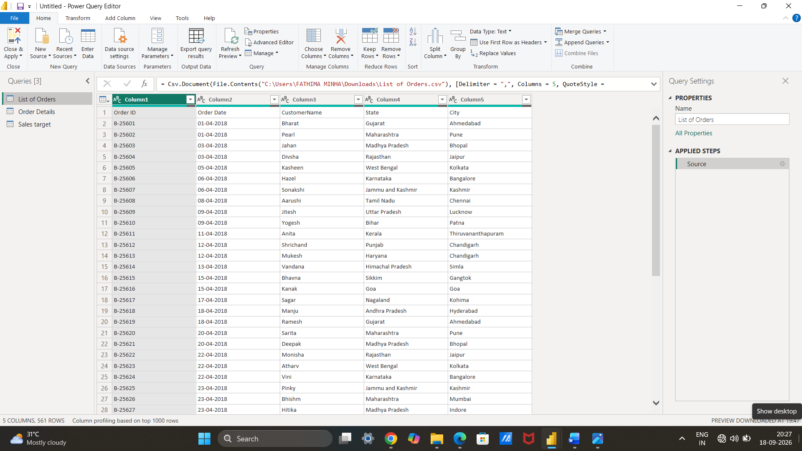
● Restrict the "List of Orders" table to only the first 500 rows.
Go to the home tab click the keep rows first 500 rows keep.
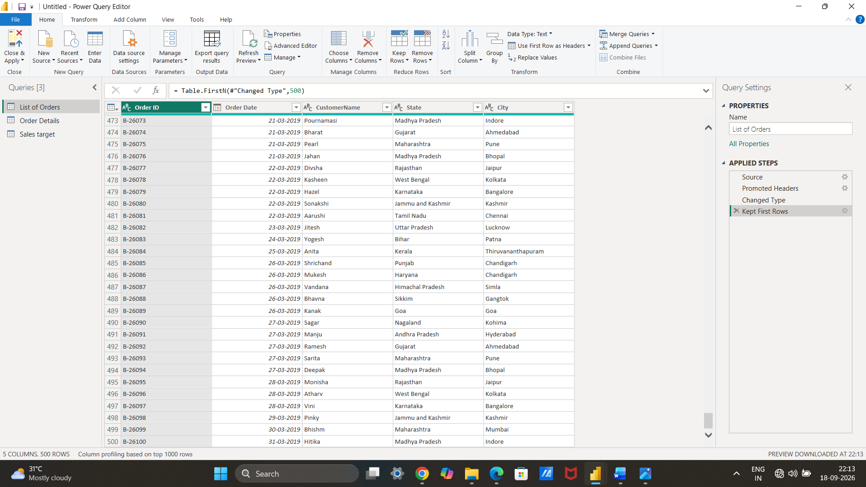
● Ensure the “Order Date” column in the “List of Orders” table is set to data type 'Date'
Select the column heading change data to date .
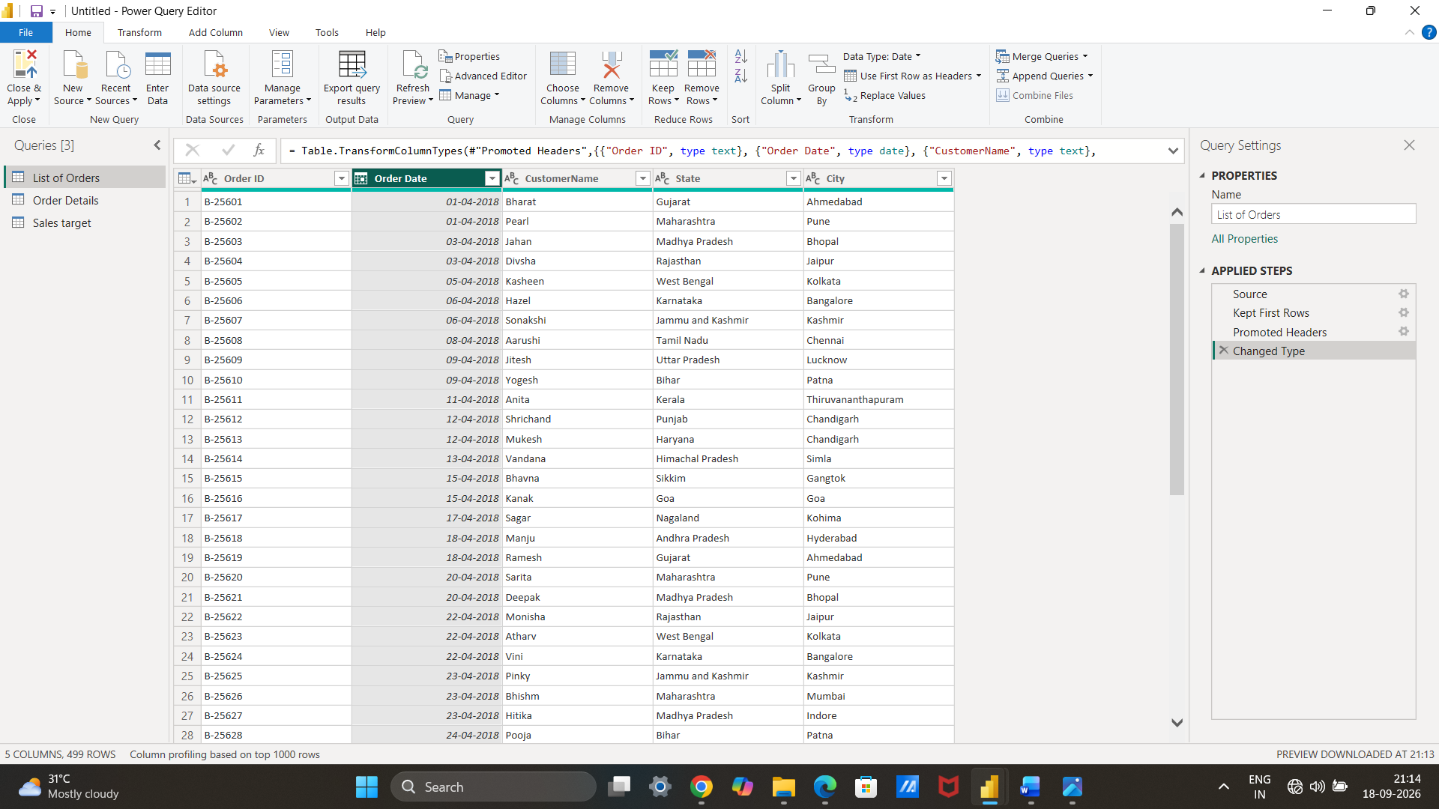
● Change the data type of “Amount” and “Target” columns to ‘Fixed Decimal Number’.
Select the heading change to fixed decimal number.
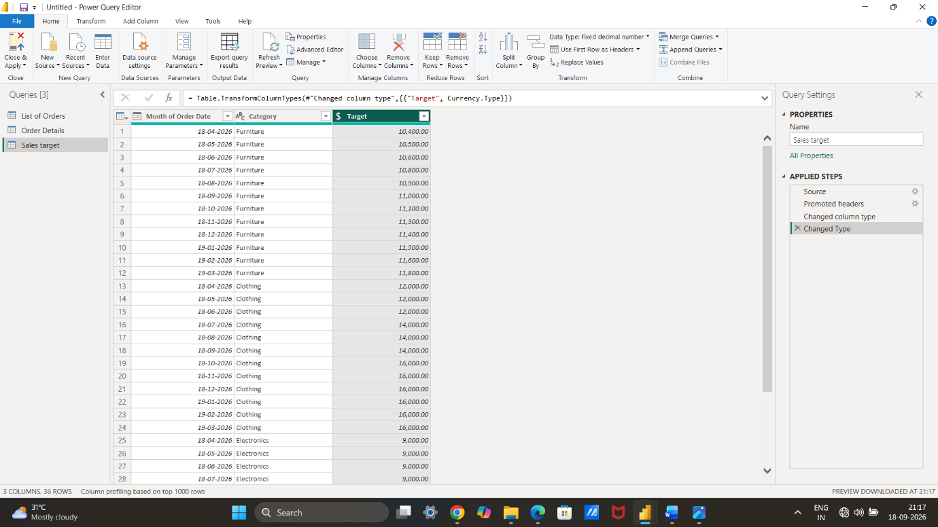
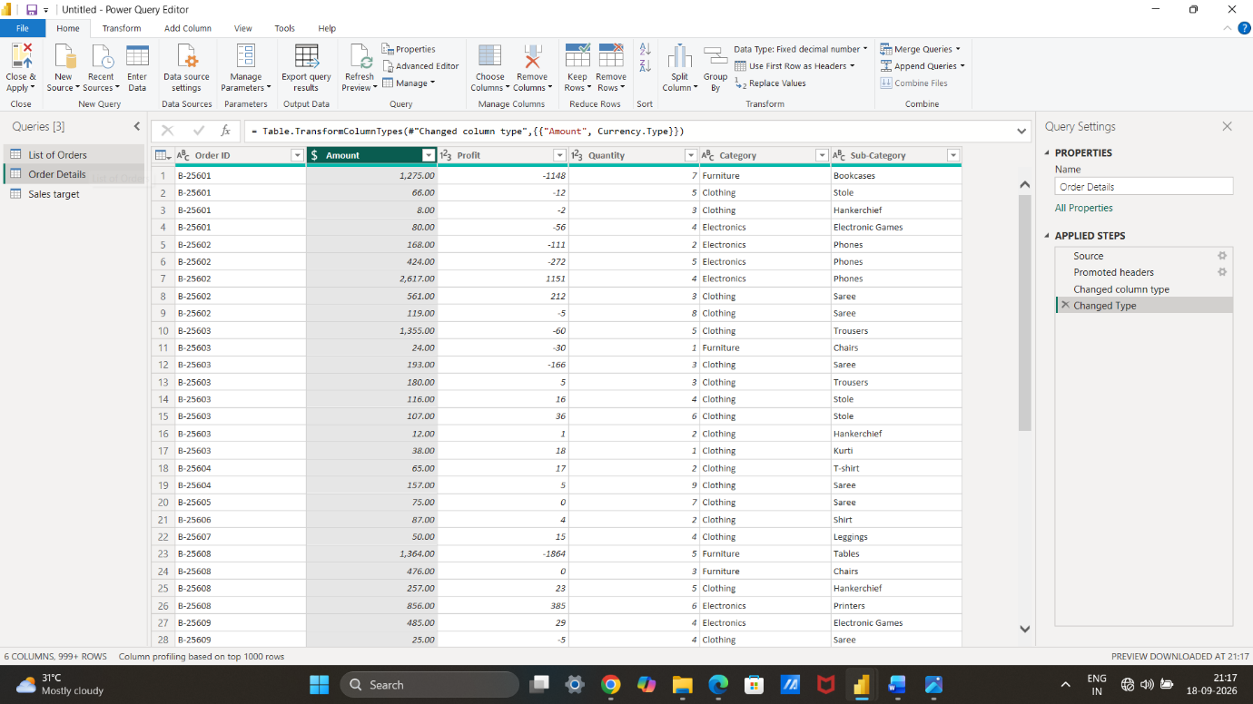
● Format the "CustomerName" column into proper case, ensuring consistent capitalization for each word.
Go to the transform click the format.
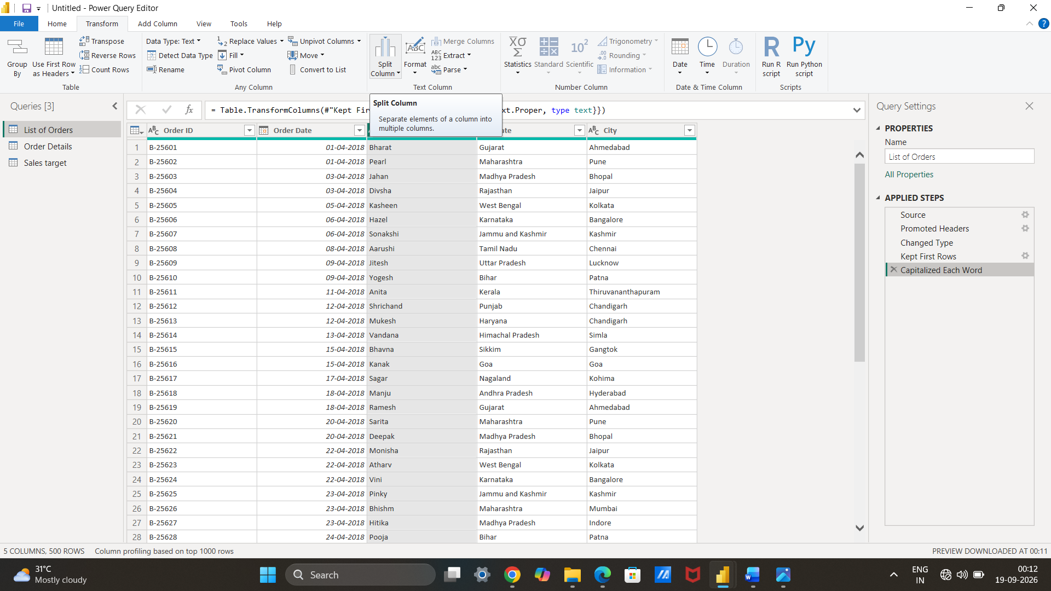
● Merge the "State" and "City" columns to create a new column named "Location" in the format ‘City, State’.
Select the city and state go to the add column click the merge columns separate with comma and name new column has location.
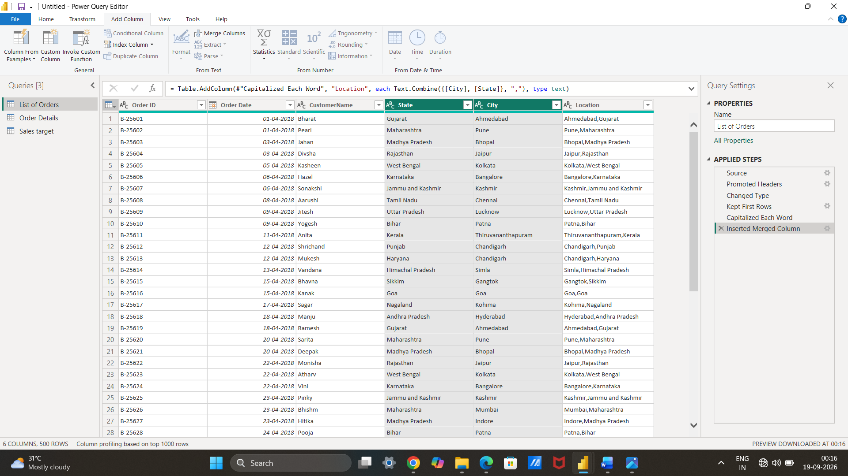
● Create a new custom column named "Profit Margin" as the percentage of "Profit" divided by "Amount".
Select the coustom column named “profit margin’”and add the formula =[profit]/[amount].And change into percentage.
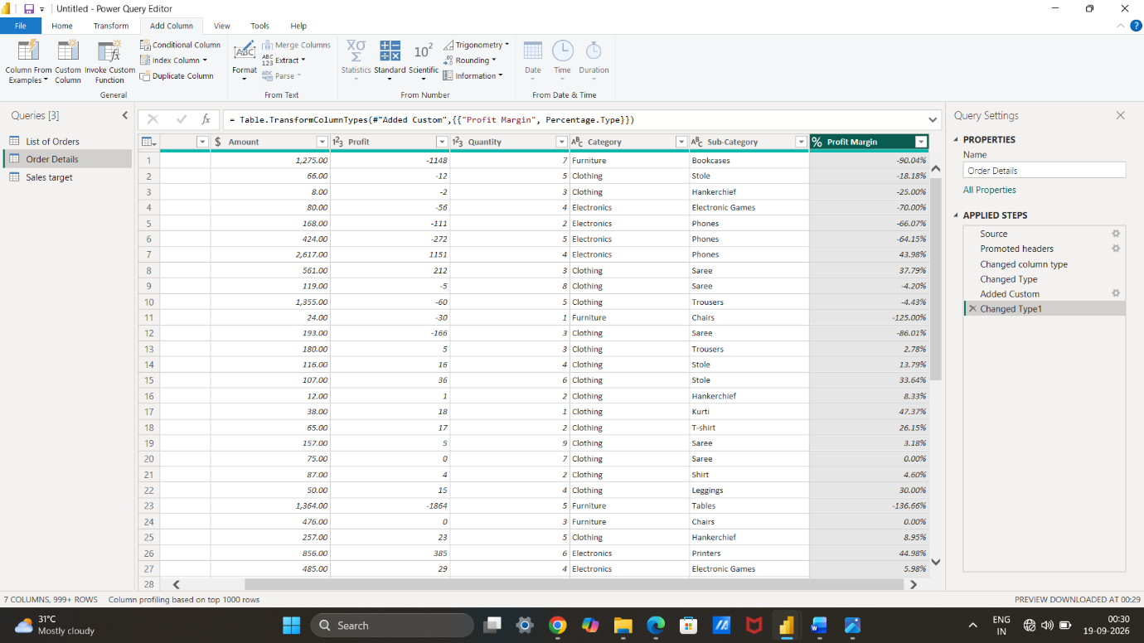
● Add a new conditional column named "Profit Status" based on the values in the "Profit" column. The conditions are as follows: if the profit is less than 0, the label should be "Loss"; if the profit equals 0, the label should be "Break-Even"; and if the profit is greater than 0, the label should be "Profit".
Go to add column click the conditional coloumn.put the conditions.
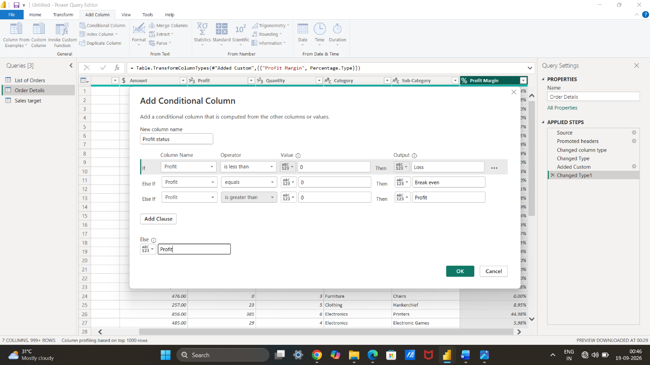
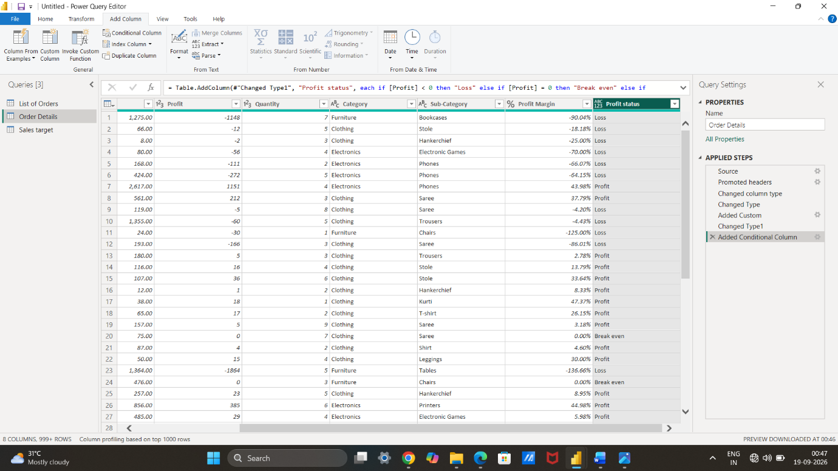
Merging Data (Joins):
● Merge the "List of Orders" and "Order Details" tables into a new single table named "Orders Data" based on the "Order ID" relationship.
Go to home tab select the merge as new select the tables and highlight the order id and name order data.
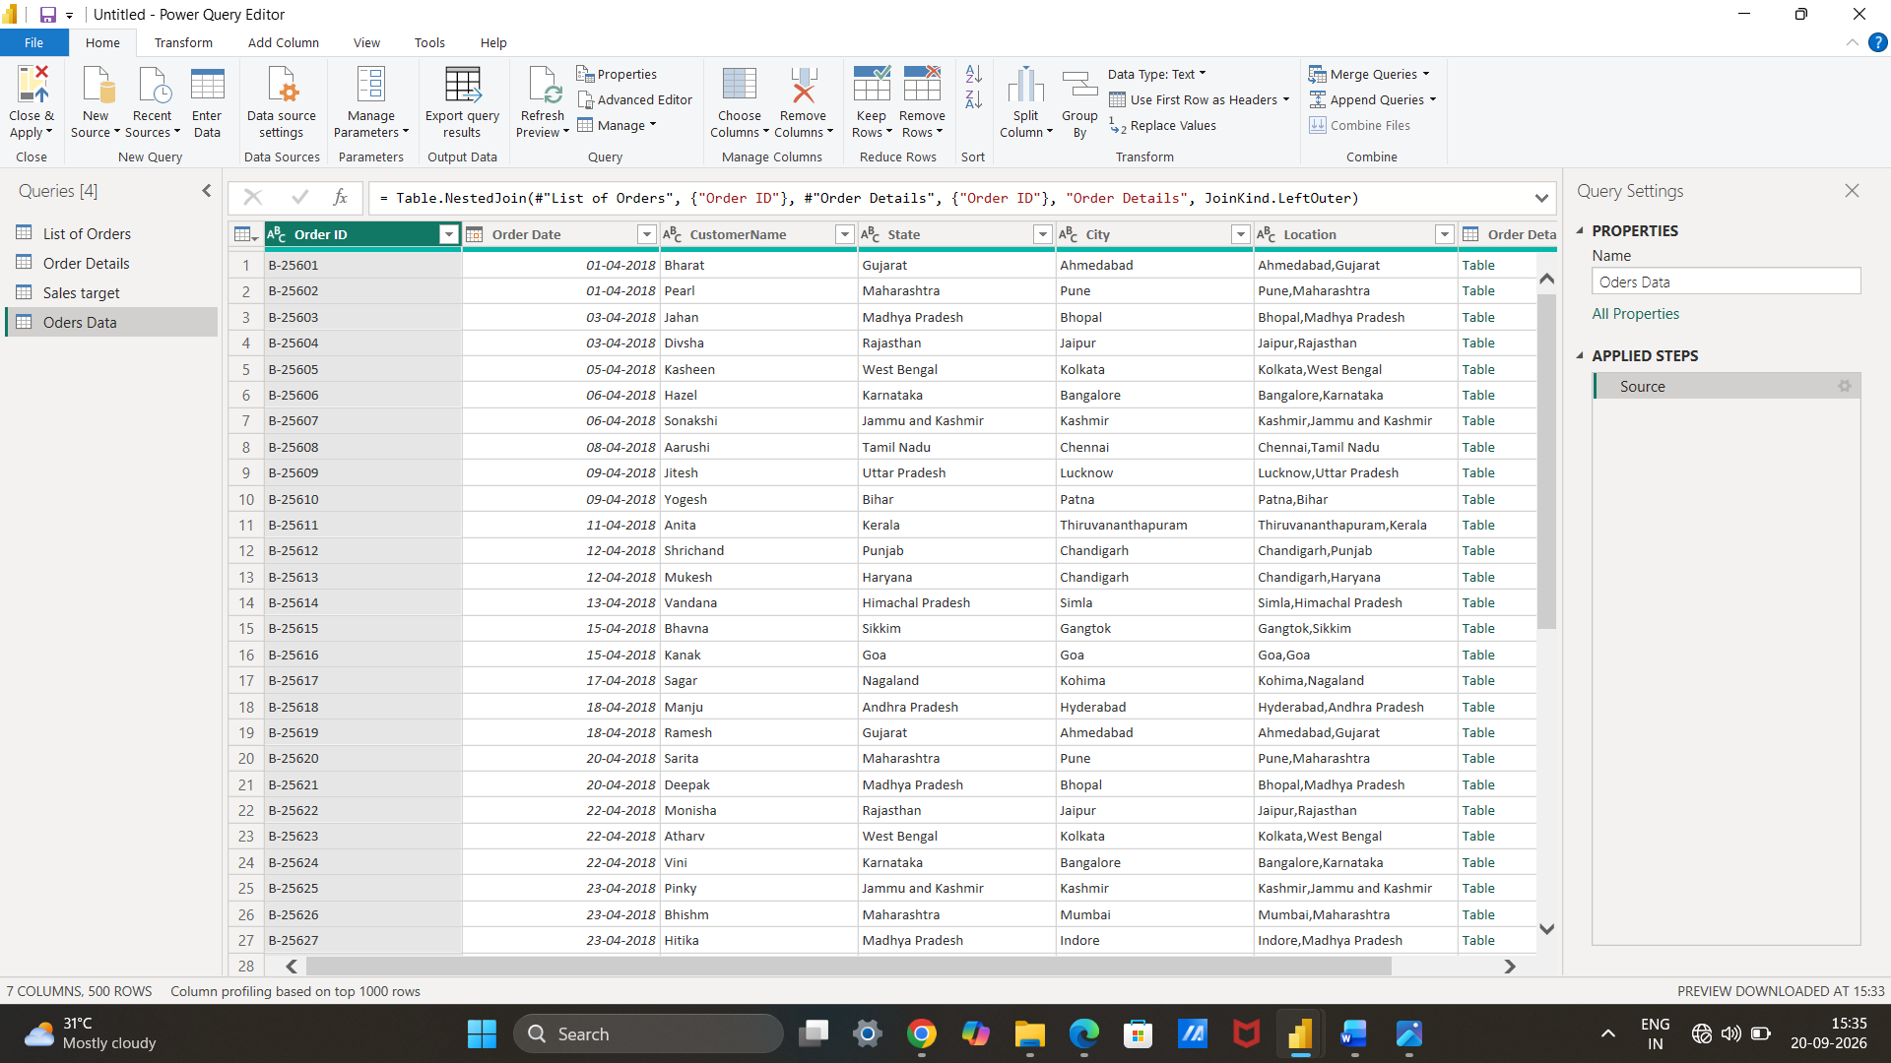
Handling Missing Data & Duplicate Data:
● Identify missing values in the data and determine a strategy to address them.
Go to view tab check colum quality.
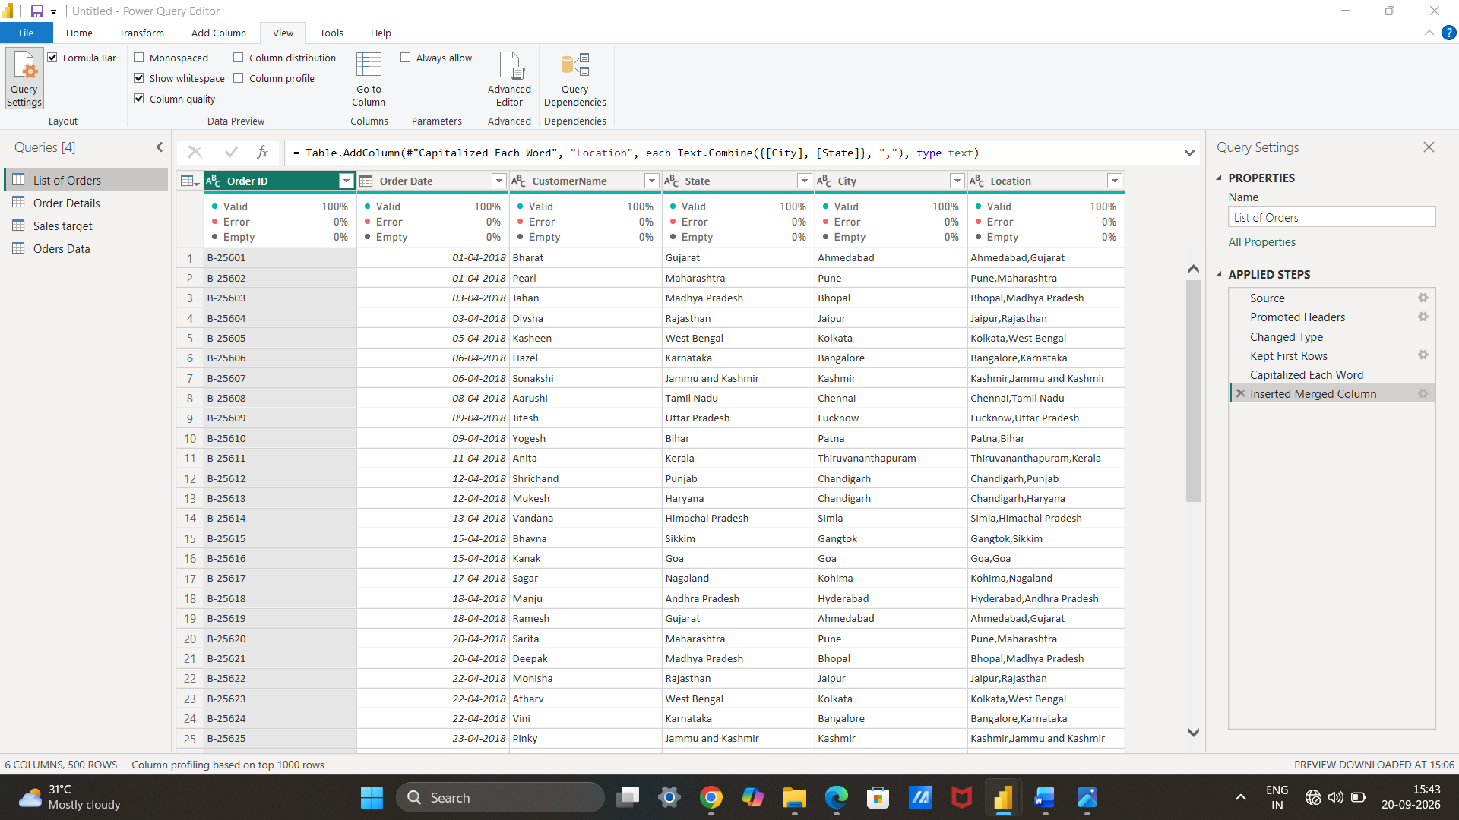● Check for duplicate rows and define a strategy to handle duplicates.
Go to the home tab remove duplicates.
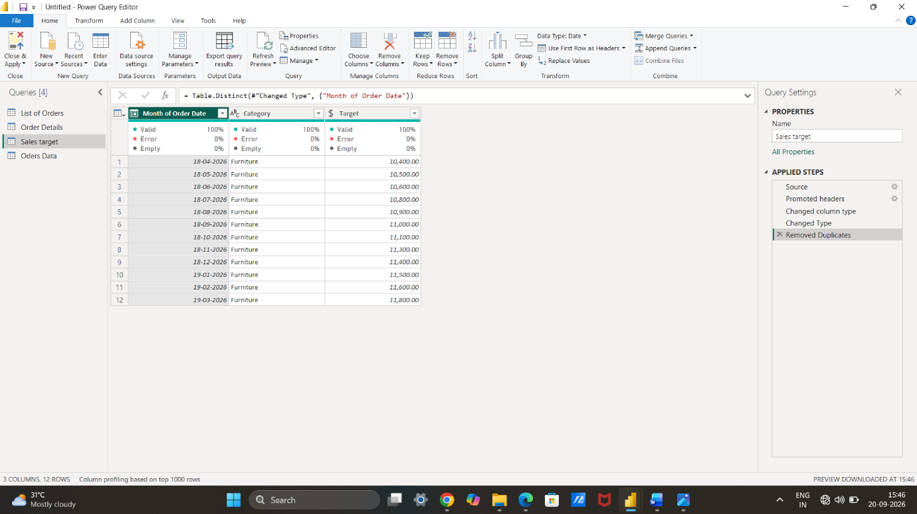◆ Sort the orders by Order Date in descending order to analyze recent trends.
Click the colum header and select the descending order.
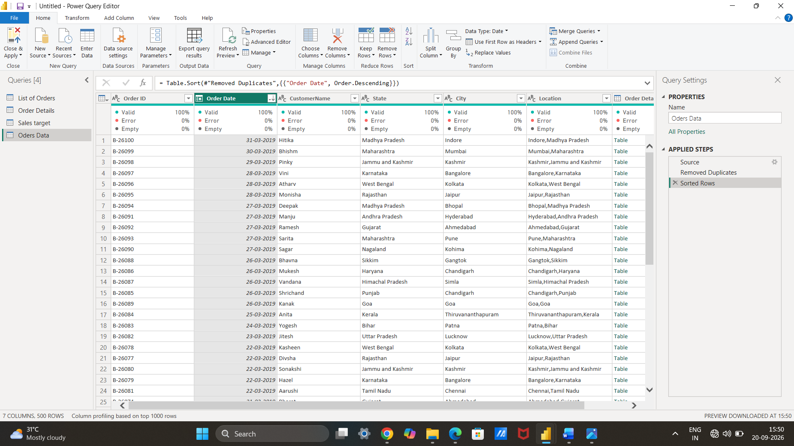
◆ Filter the orders to focus only on a specific state (e.g., Tamil Nadu) for regional analysis.
Click the column header and select the state.
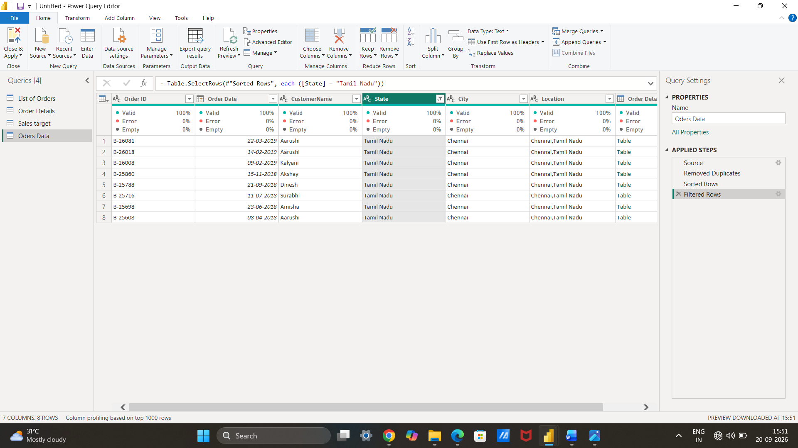
Grouping and Aggregating Data:
● Duplicate the “Order Details” table and calculate the count of each Order ID, average profit by Category or total amount by Sub-Category.
Duplicate the table .Use the advance group by method.count and average calculated.
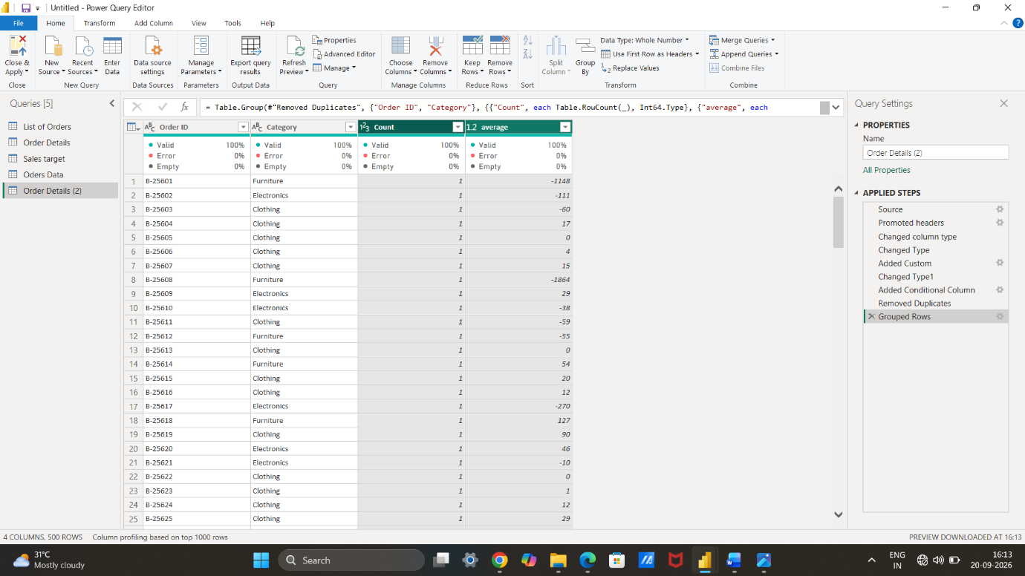
Duplicate the “Sales Target” table and aggregate the total target amount by Month of Order Date.
Duplicate the table and open the group by and add details .
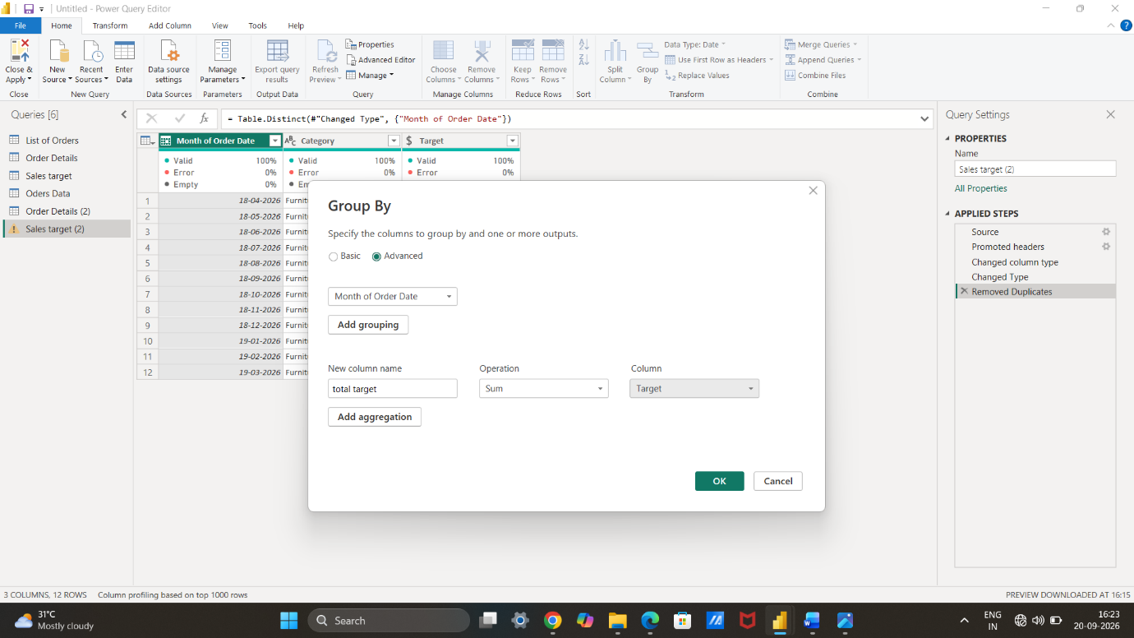
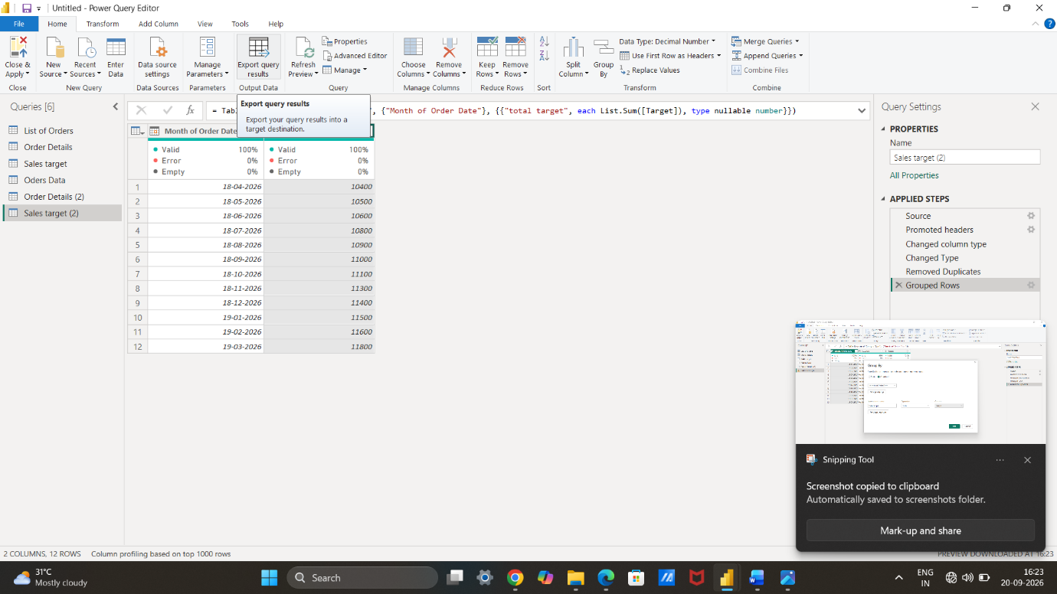
Data Modeling:
● Establish a relationship between the “List of Orders” and “Order Details” tables using the ‘Order ID’ column.
Go to home tab manage relationship make relation between order details and list of orders.
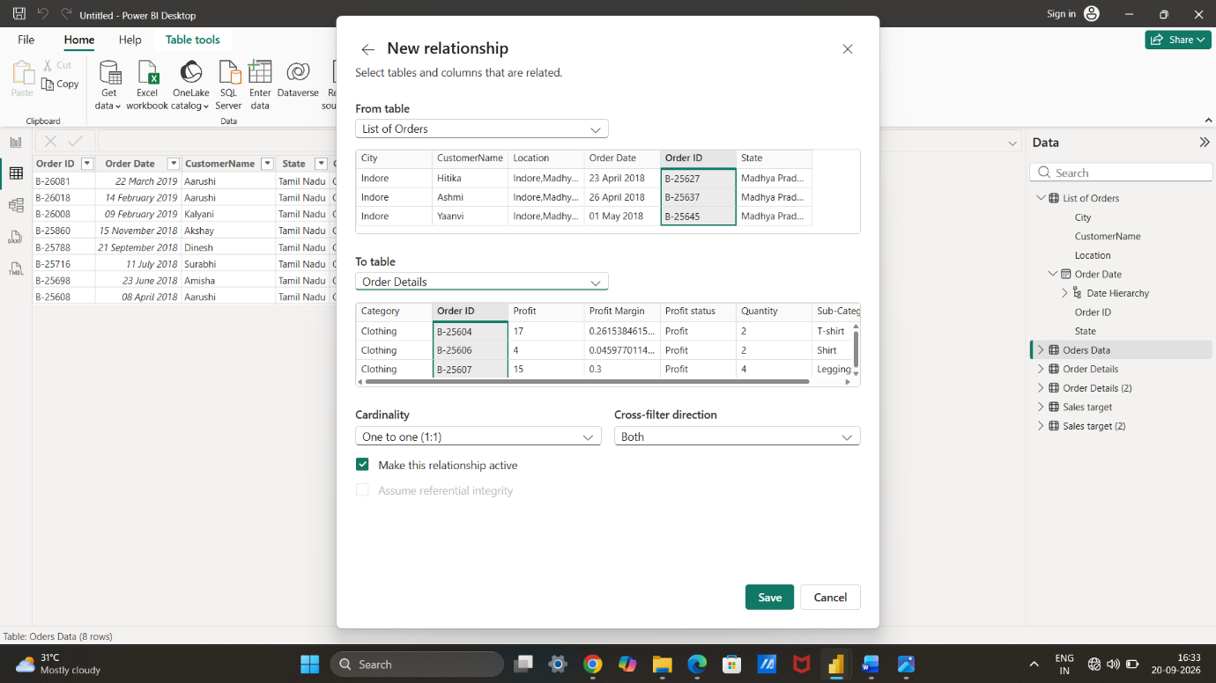
● Build a relationship between the “Order Details” and “Sales Target” tables based on the ‘Category’ column. Click "Manage relationships" and ensure this relationship is active.
Manage relationship make relation between sales target and order details basis of category.
